Project 3-4: Number Generator

Objectives
Use concepts from Chapter 3 and 4 to complete Project 3-4

Description
Create a program that takes two inputs from the user and creates a random list of 10 numbers.

Requirements
- The program should calculate:
  - Total of the numbers
  - The average of the numbers
  - The smallest number
  - The largest number
- Print out the list of numbers sorted from smallest to largest.
- Use a LIST
- Assume the user will enter valid data
- The expected output image provides the format for the program output

Expected Output
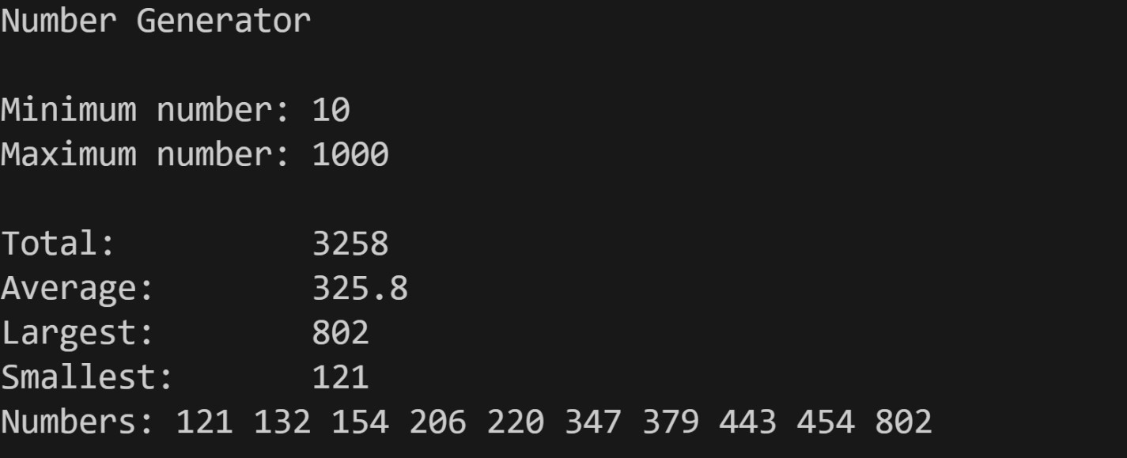

Grading Criteria
File naming convention | 5
Comments (Minimum file header comments and interior code) | 15
Use of input() function | 10
Use of F-String | 10
Use a list and list functions/methods | 20
Calculates (total, average, smallest and largest) correctly | 20
Output format | 20
Code does not compile | -50
Total | 100

Grading criteria

-5 Filename convention <student_name>_<Project name>.py
-7.5 No minimum Header comments.
-7.5 Minimum file header comments missing.
-10 Did not use F-string
-3 Print out the list of numbers sorted from smallest to largest - missing

Please review Blackboard --> Start Here --> Supplemental Materials --> Minimum source code file standard (Project Standard)
Be careful with round as 5.00 would be displayed as 5.0 vice 5.00.

Future output should look like provided "expected output".

